A Project Report

On

**JSW Ecommerce Website**

Submitted in requirement of Internship Training at

JSW Dolvi Works

**Submitted By**

**Ms. Manjiri Paresh Kothawale**

B.SC Computer Science (2nd Year)

**Pillai College of Arts, Commerce and Science**

New Panvel – 410206

**Guided By**

Mr. M V Raman (HOD IT Department)

Mr. Rajesh Srinivasan (IT Department)

 

**Department of Information Technology Department of B.SC Computer Science**

**JSW STEEL Ltd. DOLVI WORKS Pillai College of Arts,Commerce**

**Dolvi, Pen – 402107 and Science, New Panvel – 410206**



**Department of Information Technology**

**JSW STEEL Ltd. DOLVI WORKS**

**Dolvi, Pen – 402107**

To whom it may concern

This is to certify that the requirements for the application entitled

**‘JSW Ecommerce Website’** has been successfully completed by

**Manjiri Paresh Kothawale** in fulfillment of Internship Training

Completed during Year 2024 – 2025.

The project has been successfully submitted to the following signatories:

Date: 15/05/2024

**Mr. M V Raman**

(HOD, IT Department

JSW Steel Ltd. Dolvi Works)



**Department of B.Sc Computer Science**

**Pillai College of Arts, Commerce and Science**

**New Panvel – 410206**

# ACKNOWLEDGEMENT

This industrial training in JSW (Jindal Steel Works) Dolvi, Maharashtra, in Information Technology Department was a memorable one for me as it was rich in experience sharing and helped me to discover my potential. I had so many rich experiences and opportunities that I personally believe will forever shape and influence my professional life while fostering personal growth and development.

In this report, I hope to highlight the work that I have performed and learned. Working here has not only given me the industrial experiences, but also teaches me how to sustain in tough environment. Good working conditions and friendly behaviour of everyone inspires me to be productive in work.

These few details lead me to realize that, like all human endeavours, this report is not perfect and may contain errors and shortcomings. Thus, I remain open to all criticisms and suggestions which could present me with new sources of inspiration as I develop in my ability to research and learn.

This report would not have been possible without the contribution and collaboration of others. My sincere gratitude:

* Mr. M V Raman, HOD, IT, JSW Dolvi.
* Mr. Chinna Rao Kandi, IT, JSW Dolvi.

I am grateful towards Training Department, JSW Dolvi Works for considering me eligible and giving me the opportunity to showcase my talent and learn new skills.

To all of you, I extend my deepest gratitude and always owe my respect to them.

# TABLE OF CONTENTS

|  |  |  |
| --- | --- | --- |
| Sr. No. | Content | Page No. |
| 1 | Overview of Company | 1 |
| 2 | Project Overview | 3 |
| 3 | Technical Stack | 3 |
| 4 | Architecture | 4 |
| 5 | Technologies used (PHP, AJAX, jQuery,MySQL) | 5 |
| 6 | Flow-Chart | 10 |
| 7 | Detailed Approach 1. Login Page | 11 |
| 8 | Detailed Approach 2. Register User | 12 |
| 9 | Detailed Approach 3. Shop Page | 14 |
| 10 | Detailed Approach 4. Inquiry Page | 17 |
| 11 | Detailed Approach 5. Logout Functionality | 20 |
| 12 | Detailed Approach 6. Home Page | 21 |
| 13 | Detailed Approach 7. About us Page | 24 |
| 14 | Detailed Approach 8. Projects Page | 26 |
| 15 | Detailed Approach 9. Blogs Page | 27 |
| 16 | Detailed Approach 10. Contact us Page | 28 |
| 17 | Database | 30 |
| 18 | Deployment | 32 |
| 19 | SWOT Analysis | 35 |
| 20 | Conclusion | 36 |

**OVERVIEW OF COMPANY**

JSW Steel Ltd. is an Indian [steel](https://en.wikipedia.org/wiki/Steel) making company based in [Mumbai, Maharashtra](https://en.wikipedia.org/wiki/Mumbai%2C_Maharashtra). It is a subsidiary of [JSW Group](https://en.wikipedia.org/wiki/JSW_Group). It is one of the fastest growing companies in India with a footprint in over 140 countries. JSW Steel is an Indian steel company owned by the JSW Group based in [Mumbai, Maharashtra](https://en.wikipedia.org/wiki/Mumbai%2C_Maharashtra), India. JSW Steel, after merger of ISPAT steel, has become India's second largest private sector steel company. The current installed capacity is 18 MTPA. A $13 billion conglomerate, with presence across India, USA, South America & Africa, the JSW Group is a part of the O.P. Jindal Group with strong footprints across core economic sectors, namely, Steel, Energy, Infrastructure, Cement, Ventures and Sports.

**History:**

JSW Steel's history can be traced back to 1982, when the Jindal Group acquired Piramal Steel Limited, which operated a mini steel mill at Tarapur in Maharashtra and renamed it as Jindal Iron and Steel Company (JISCO). Soon after the acquisition the group set up its first steel plant in 1982 at Vasind, near Mumbai.

Later, in 1994, Jindal Vijayanagar Steel Limited (JVSL) was set up with its plant located at Toranagallu in the Bellary-Hospet area in the State of Karnataka, the heart of the iron ore belt and spread over 10,000 acres (40 km2) of land. It is well connected to both the Mormugao Port and Chennai Port and is 340 kilometres from Bangalore. It is said to be the sixth largest steel plant in the world.

In the year 2005, JISCO and JVSL merged to form JSW Steel Limited. It also set up a plant at Salem with an annual capacity of 1 million tonnes.

**Operations:**

As of July 2023, the installed with a production capacity of 29.7 MTPA in India and the United States. The company is aiming to boost the total steel production capacity to 38.5 MTPA by the financial year 2025.

As of April 2023, nearly 98% of JSW Steel's revenue comes from steel and related products — long rolled products (18%), galvanised coils/sheets (15%), CR coils/sheets (9%), plates/pipes (5%), other miscellaneous steel products (5%), and iron ore (2%), in that order. Overall, 70% of revenue is derived from India, and 30% is from overseas. The company historical emphasis has primarily been on flat products, stemming from its origins in a cold rolling mill. As part of its corporate strategy, the company typically directs half of its flat products to downstream facilities for additional value-enhancing processes like galvanizing, coating, or tinning.

**Plants:**

**JSW Vijaynagar Works** (also known as Integrated Steel Plant, Vijaynagar): It is a flagship plant of the company, which also stands as the largest single-location steel manufacturing unit across India. At present, the plant is in the midst of a brownfield expansion aimed at increasing its current capacity from 13 MTPA to 18 MTPA by FY24. This expansion will cover 600 acres and involve the addition of a 4.5 MTPA blast furnace, two steel melt shops of 350 tonnes each, a 5 MTPA hot strip mill, alongside various other related facilities. In 2017-2018, a new ladle furnace slag recycling process was adopted at Vijayanagar Works as part of a new environmental and waste disposal strategy. The report highlighted eliminating specific synthetic slag consumption at 1.2 kg per ton of liquid steel.

**JSW Dolvi Works** (also known as Integrated Steel Plant, Dolvi): This plant was acquired by the company in 2010 from Ispat Steel for $3 billion. It was first Indian steel plant to adopt a combination of ConArc technology for both steel-making and compact strip production. Whereas a blast furnace transforms iron ore into steel, ConArc utilizes iron pellets, which are essentially one step processed iron ore. In 2022, Dolvi Works obtained security protection from the Central Industrial Security Force. At that time, it was the 13th industrial facility in the private sector in India to be placed under CISF security apparatus.

**JSW Sambalpur Works** (also known as Integrated Steel Plant, Rengali): This plant was acquired by the company in 2019 after the liquidation of Bhushan Power & Steel by National Company Law Tribunal. It added 3.5 MTPA to overall steel production capacity of the company.

**JSW Salav Works**: This plant was previously was owned by Welspun Group and it was purchased by the JSW Steel in 2014 for ₹1,000 crore (US$130 million). It is located in near vicinity (within 40 km) of the JSW Dolvi Works.

JSW Kalmeshwar Works: It is India's first coated steel manufacturing facility, producing galvanized, Galvalume, and pre-painted galvanized/galvalume steel. The plant was acquired by the company from Ispat Steel, is situated 30 kilometers from Nagpur in Central India.

**JSW Tarapur Works**: It is country's largest single location coated steel plant which manufactures of ultra thin coated products such as pre-painted galvanised/galvalume, galvanised and bare galvalume steel. It is located about 100 kilometers from Mumbai.

JSW Vasind Works: The facility, situated 70 kilometers from Mumbai, is a complex equipped with cold rolling, galvanizing, and color coating capabilities.

**JSW Salem Works:** The plant is located 350 kilometers from Chennai, is known for producing special alloy steel.

**PROJECT OVERVIEW**

The JSW Shop project is a comprehensive ecommerce website developed specifically for showcasing and selling products manufactured by JSW Steel. It serves as an online platform where users can browse through a wide range of products, obtain detailed information about each product, and make inquiries or purchases as per their requirements. The project is designed to cater to the growing demand for online shopping experiences in the steel industry, particularly focusing on the needs of JSW Steel's customers.

**Objectives and Goals:**

1. Improving Customer Experience: The primary objective of the JSW Shop project is to enhance the overall customer experience by providing a user friendly interface, intuitive navigation, and engaging product displays. Features such as detailed product descriptions, high quality images, and user reviews aim to create a seamless and enjoyable shopping journey for users.
2. Increasing Sales: Another key goal of the project is to boost sales for JSW Steel by offering an efficient online platform for product showcasing and sales. The website is optimized to encourage conversions, with clear call to action buttons, secure payment gateways, and personalized recommendations based on user preferences.
3. Streamlining Operations: The project also focuses on streamlining various operational aspects, including order management, inventory tracking, and customer support. Integration with backend systems allows for real time updates on product availability, order processing, and delivery tracking, ensuring smooth and efficient operations.

**TECHNICAL STACK**

**Frontend:**

* HTML (Hyper-Text Markup Language): HTML is used to structure the content of web pages. It defines the elements such as headings, paragraphs, lists, images, and links that make up the layout of the website.
* CSS (Cascading Style Sheets): CSS is responsible for styling the HTML elements, including setting colors, fonts, spacing, layouts, and responsive design aspects. It ensures a consistent and visually pleasing presentation of the website across different devices and screen sizes.
* JavaScript: JavaScript adds interactivity to the website. It is used for implementing dynamic features such as form validation, dropdown menus, image sliders, interactive forms, and client side data manipulation.
* Bootstrap: Bootstrap is a frontend framework that provides predesigned components, grid systems, and CSS stylesheets. It is used in JSW Shop to create a responsive and mobile friendly design, ensuring that the website adapts well to various devices, including desktops, smartphones.

**Backend:**

The backend of the JSW Shop project is powered by technologies that handle server side logic, data processing, and communication with the frontend:

* PHP (Hypertext Preprocessor): PHP is a server side scripting language used for generating dynamic web pages. It interacts with the database, processes user inputs, and performs server side operations such as form handling, data validation, and session management.
* AJAX (Asynchronous JavaScript and XML): AJAX is employed for asynchronous communication between the client (web browser) and the server. It allows parts of the web page to be updated dynamically without requiring a full page reload. AJAX is used in JSW Shop for features like live product search, real time updates, and interactive forms.

**Database:**

The database technology utilized in JSW Shop for data storage, retrieval, and management is:

* MySQL: MySQL is a popular relational database management system (RDBMS) known for its scalability, performance, and reliability. It is used to store and organize data related to products, user accounts, orders, inventory, and other aspects of the ecommerce platform.

**Other Tools and Technologies:**

In addition to the core technologies mentioned above, JSW Shop may also incorporate the following tools, libraries:

* jQuery: jQuery is a JavaScript library that simplifies DOM manipulation, event handling, and AJAX requests. It enhances the frontend functionality by providing shortcuts for common tasks and cross browser compatibility.

**Server:**

The JSW Shop project is hosted and tested using XAMPP, which is a free and opensource cross platform web server solution stack. XAMPP includes Apache as the web server, MySQL as the database management system, and PHP for server side scripting. It provides an environment for local development and testing of web applications before deployment to a live server.

**ARCHITECTURE**

**Database Schema and Structure**

The database schema and structure of the JSW Shop project define how data is organized, stored, and accessed within the MySQL database:

* Tables and Relationships: The database schema includes tables for storing product information, user data (e.g., customer details, order history), cart items, categories, and other relevant entities. Relationships between tables (e.g., one to many, many to many) are defined using foreign keys to maintain data integrity and enforce referential integrity constraints.
* Data Storage and Retrieval: Data is stored in normalized database tables to minimize redundancy and improve data consistency. SQL queries are used to retrieve and manipulate data, including SELECT, INSERT, UPDATE, and DELETE operations. Indexes are applied to optimize query performance for frequent data retrieval operations.

**Integration of Components:**

The integration of frontend, backend, and database components in the JSW Shop project ensures a cohesive and seamless ecommerce platform:

* Frontend-Backend Communication: Frontend components interact with backend scripts (PHP) via HTTP requests (GET, POST) to send user inputs, retrieve data, and receive server responses. Form submissions, product searches, and user actions trigger backend operations.
* Database Integration: Backend scripts interact with the MySQL database to perform CRUD (Create, Read, Update, Delete) operations on data. SQL queries are executed to fetch product details, update user information, manage orders, and maintain inventory levels.
* Session Management: Sessions are used to maintain user authentication and session state across multiple requests. User sessions are managed securely to track logged in users, store session data, and maintain user context throughout the browsing and shopping experience.

**PHP (Hypertext Preprocessor)**

PHP (Hypertext Preprocessor) is a widely used open source server-side scripting language that is particularly well suited for web development.

**1.Purpose and Use:**

* PHP is primarily used for developing dynamic web pages and web applications.
* It can generate dynamic page content, interact with databases, handle form data, manage sessions, and perform various server-side tasks.

**2. Syntax:**

* PHP code is embedded within HTML or can be standalone (when used in files with a `.php` extension).
* PHP code starts with `<?php` and ends with `?>`.
* Variables in PHP start with a dollar sign (`$`) followed by the variable name.

**3. Key Features:**

* Server-Side Scripting: PHP is executed on the server, generating HTML output sent to the client's browser.
* Database Integration: It supports a wide range of databases, including MySQL, PostgreSQL, SQLite, etc., allowing seamless database operations.
* Session Management: PHP can manage session variables to track user data across multiple pages.
* Form Handling: It can process form data submitted by users via POST or GET methods.
* File Handling: PHP can read, write, and manipulate files on the server.
* Security: PHP offers built in security features like data sanitization, input validation, and protection against common vulnerabilities like SQL injection and XSS (CrossSite Scripting).
* Object Oriented Programming (OOP): PHP supports OOP principles, allowing developers to write modular and reusable code.

**4. Development Environment:**

* PHP scripts are executed on a web server configured with PHP support (e.g., Apache, Nginx).
* Local development environments like XAMPP, WAMP, or MAMP provide a setup for testing PHP applications on a personal computer before deploying them to a live server.

**AJAX (Asynchronous JavaScript and XML)**

**1. Purpose and Use:**

* AJAX is a technique for creating dynamic and interactive web applications without reloading the entire page.
* It allows asynchronous communication between the client (browser) and server, enabling data retrieval and updates in the background.

**2. Key Features:**

* Asynchronous Operations: AJAX requests can be sent and processed asynchronously, without blocking the user interface.
* Data Exchange: AJAX enables exchanging data with a server in various formats like JSON, XML, HTML, or plain text.
* Partial Page Updates: It can update parts of a web page dynamically, improving user experience and reducing bandwidth usage.
* Enhanced Interactivity: AJAX facilitates interactive features like live search, autocomplete, real time data updates, etc.
* Form Submission: It can handle form submissions asynchronously, providing instant feedback without page reloads.
* Error Handling: AJAX supports error handling mechanisms for managing failed requests and displaying appropriate messages.

**3. Implementation:**

* AJAX is implemented using JavaScript and XMLHttpRequest (XHR) object or newer APIs like Fetch API or Axios.
* jQuery also provides simplified AJAX methods for making asynchronous requests, abstracting the complexities of XHR handling.

1. **Common Use Cases:**

* Fetching Data: Retrieving data from a server for updating content (e.g., news feeds, product listings).
* Form Submission: Submitting form data in the background and displaying results without page reloads.
* Real Time Updates: Updating chat messages, notifications, live scores, etc., without refreshing the entire page.
* Dynamic Content Loading: Loading content dynamically based on user actions (e.g., infinite scroll, tabbed interfaces).

**jQuery**

**1. Purpose and Use:**

* jQuery is a fast, lightweight JavaScript library designed to simplify HTML document traversal, manipulation, event handling, and animation.
* It provides an easy to use API for common JavaScript tasks, reducing code complexity and improving development efficiency.

**2. Key Features:**

* DOM Manipulation: jQuery simplifies DOM manipulation tasks such as selecting elements, changing content, styles, attributes, etc.
* Event Handling: It offers streamlined methods for event handling, like click, hover, submit, etc., across different browsers.
* AJAX Operations: jQuery includes AJAX methods (`$.ajax`, `$.get`, `$.post`, etc.) for making asynchronous requests and handling responses.
* Animation Effects: jQuery provides built in animation effects and methods for creating interactive and visually appealing UI elements.
* Cross Browser Compatibility: jQuery abstracts browser specific differences, ensuring consistent behavior and compatibility across browsers.
* Plugins and Extensions: jQuery has a vast ecosystem of plugins and extensions for extending its functionality and adding advanced features.

**3. Usage:**

* Include jQuery library in your HTML file using a `<script>` tag from a CDN or local source.
* Use jQuery selectors (`$()`) to target and manipulate DOM elements, apply CSS styles, attach event handlers, etc.
* Utilize jQuery methods and functions for AJAX operations, animations, DOM traversal, manipulation, and utility tasks.

**4. Common Use Cases:**

* DOM Manipulation: Updating UI elements, adding/removing classes, handling user interactions.
* Event Handling: Responding to user actions like clicks, scrolls, form submissions, etc.
* AJAX Requests: Making asynchronous requests to fetch or submit data without page reloads.
* Form Validation: Validating form inputs, displaying error messages, and handling form submissions.

**MySQL**

**1. Purpose and Use:**

* MySQL is an opensource relational database management system (RDBMS) widely used for storing, managing, and retrieving structured data.
* It is commonly used in web development for powering dynamic websites, content management systems (CMS), ecommerce platforms, and more.

**2. Key Features:**

* Relational Database: MySQL follows the relational model, organizing data into tables with defined relationships (primary keys, foreign keys).
* Structured Query Language (SQL): MySQL uses SQL for querying and manipulating data, supporting a wide range of SQL commands and functions.
* Data Security: It provides robust data security features including user authentication, access control, encryption, and data integrity checks.

**FLOWCHART**

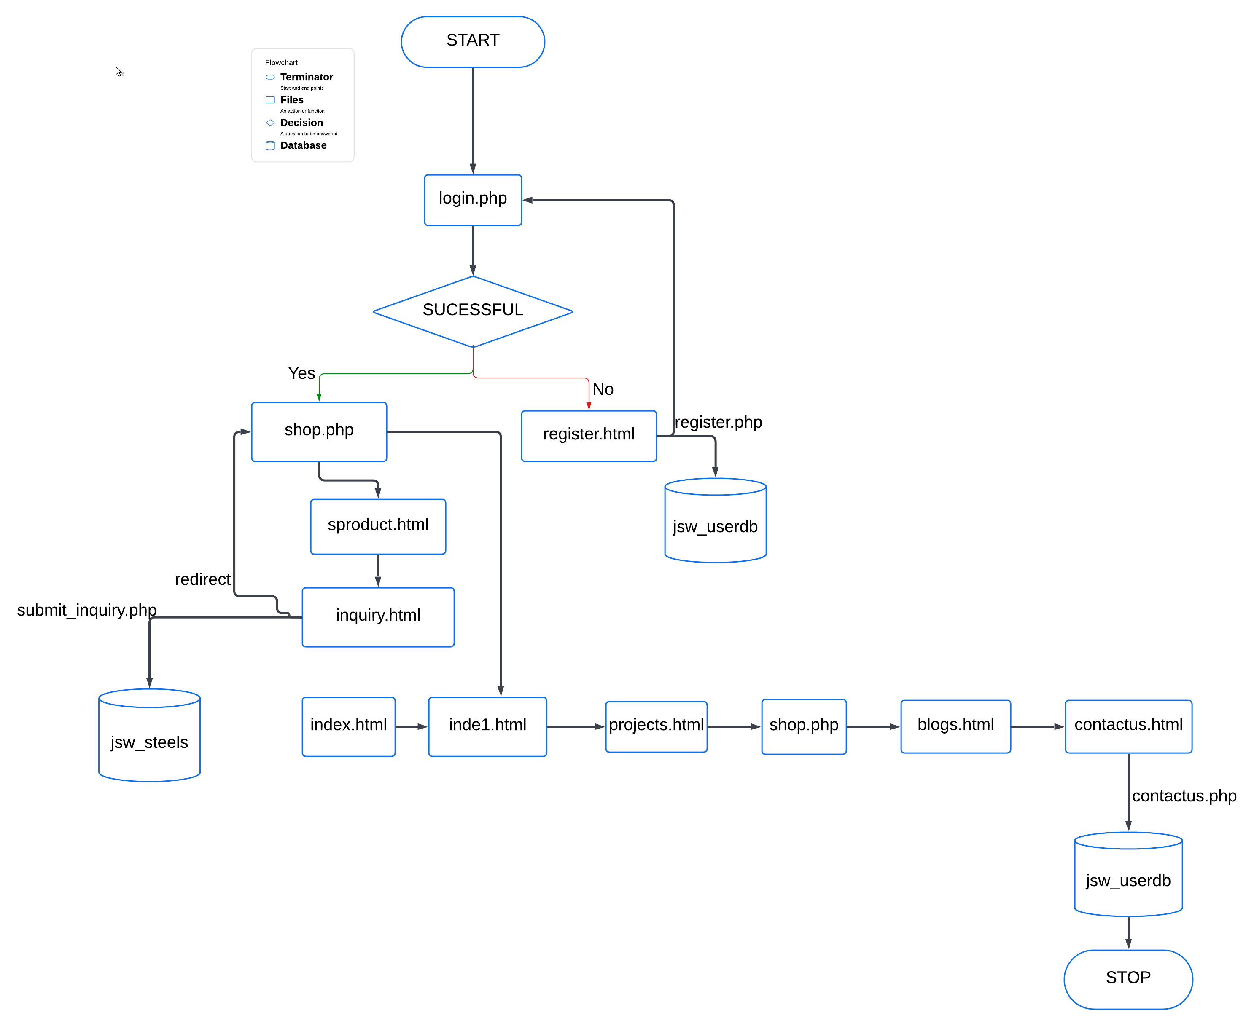

**DETAILED APPROACH**

1. **Login page:**

This is the initial page users encounter when accessing the website. It serves as the gateway to the main web application, requiring users to input their credentials to proceed.

* User Interaction: Upon opening the page, users are prompted to enter their user ID and password. These fields are mandatory for accessing the site.
* Error Handling: If a user enters incorrect credentials, such as an invalid user ID or password, the page provides a warning message indicating the mismatch. This feedback helps users identify and correct login errors.
* Navigation: Upon successful login, users are redirected to the main shop page (shop.php), where they can browse and interact with the ecommerce platform. For new users without an account, the page includes a link to the registration page (register.php), encouraging them to create an account to access the full features of the website.

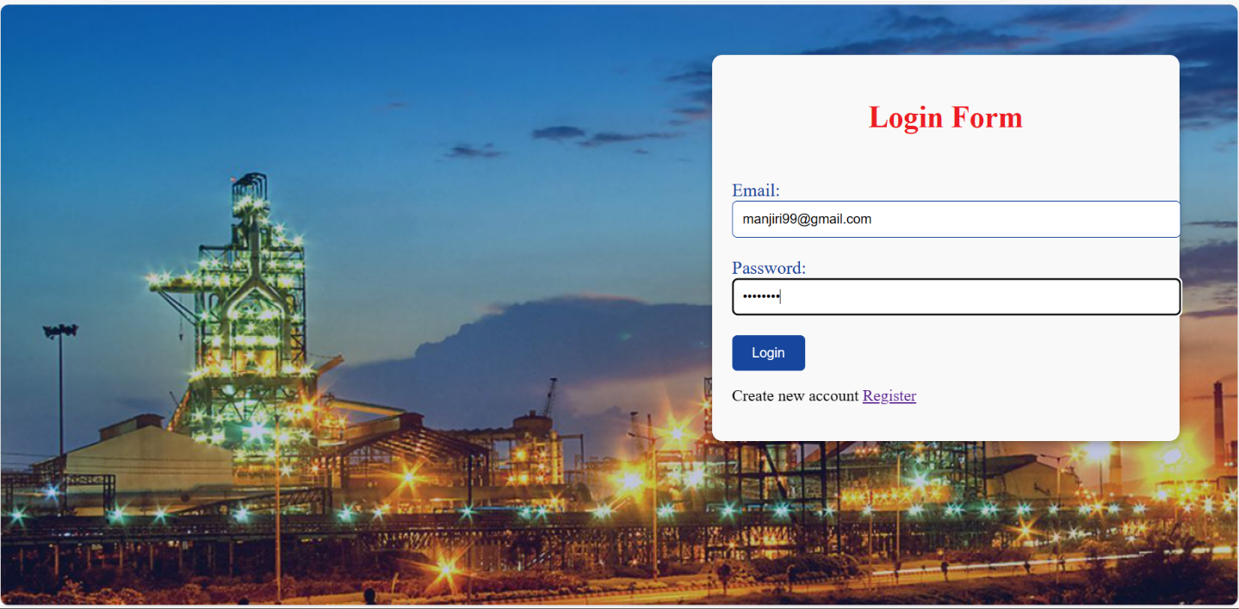

1. **Registration page:**

The registration page 'register.html' enables users to sign up for an account by providing their full name, email, and password. The page validates email format and password complexity with the help of javascript validation, ensuring a secure registration process. Upon successful registration, user information is stored in the 'users' table of the 'jsw_userdb' database with the help of php. After registration, users are redirected to the login page to access the website.

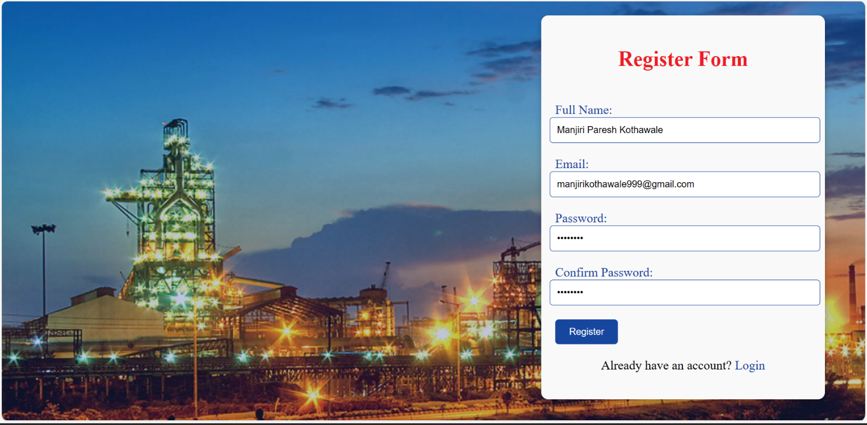

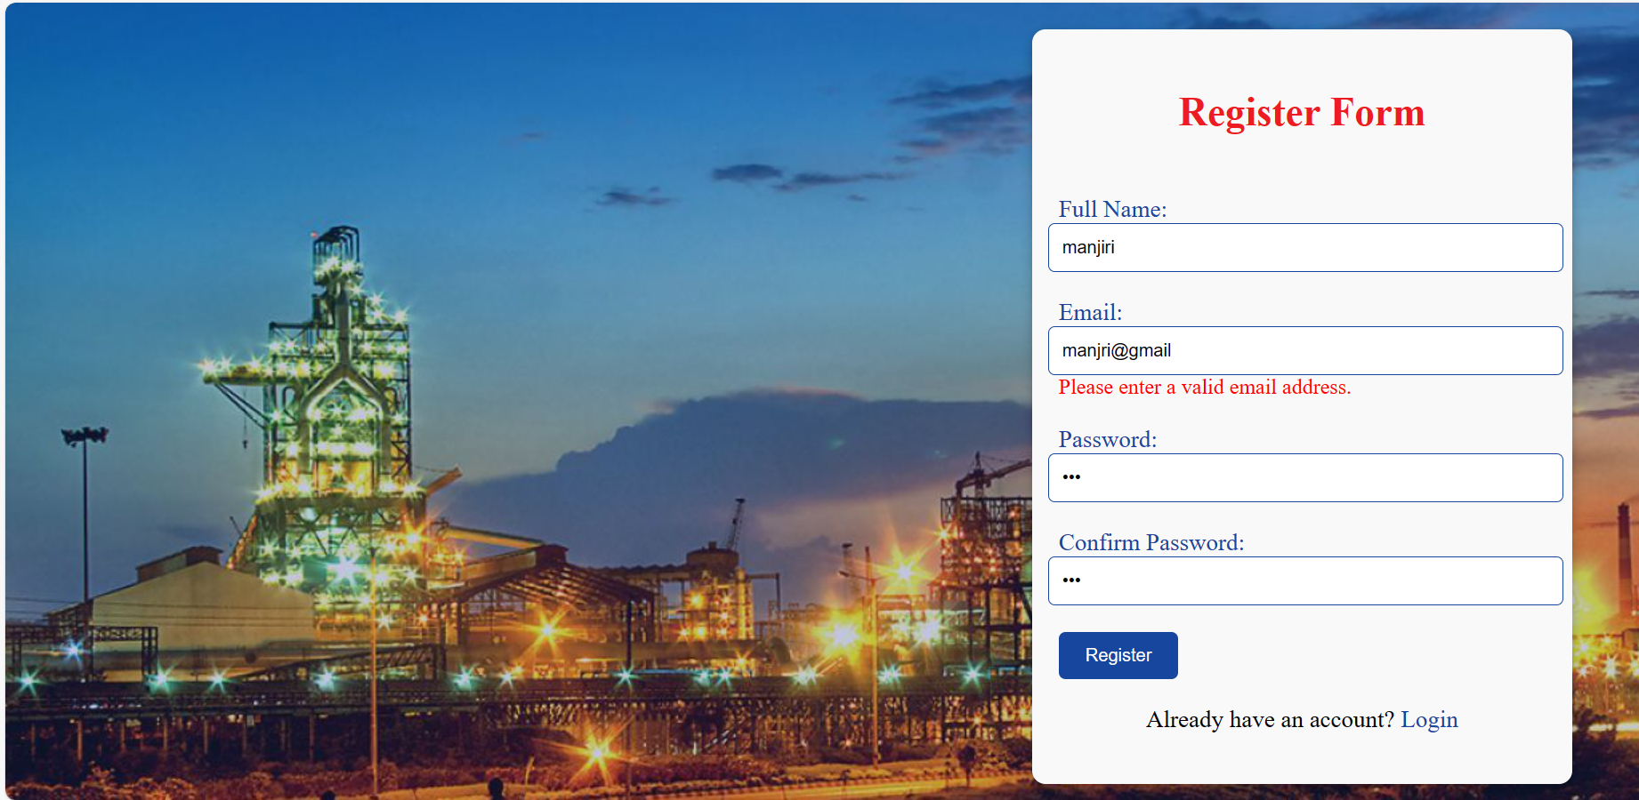

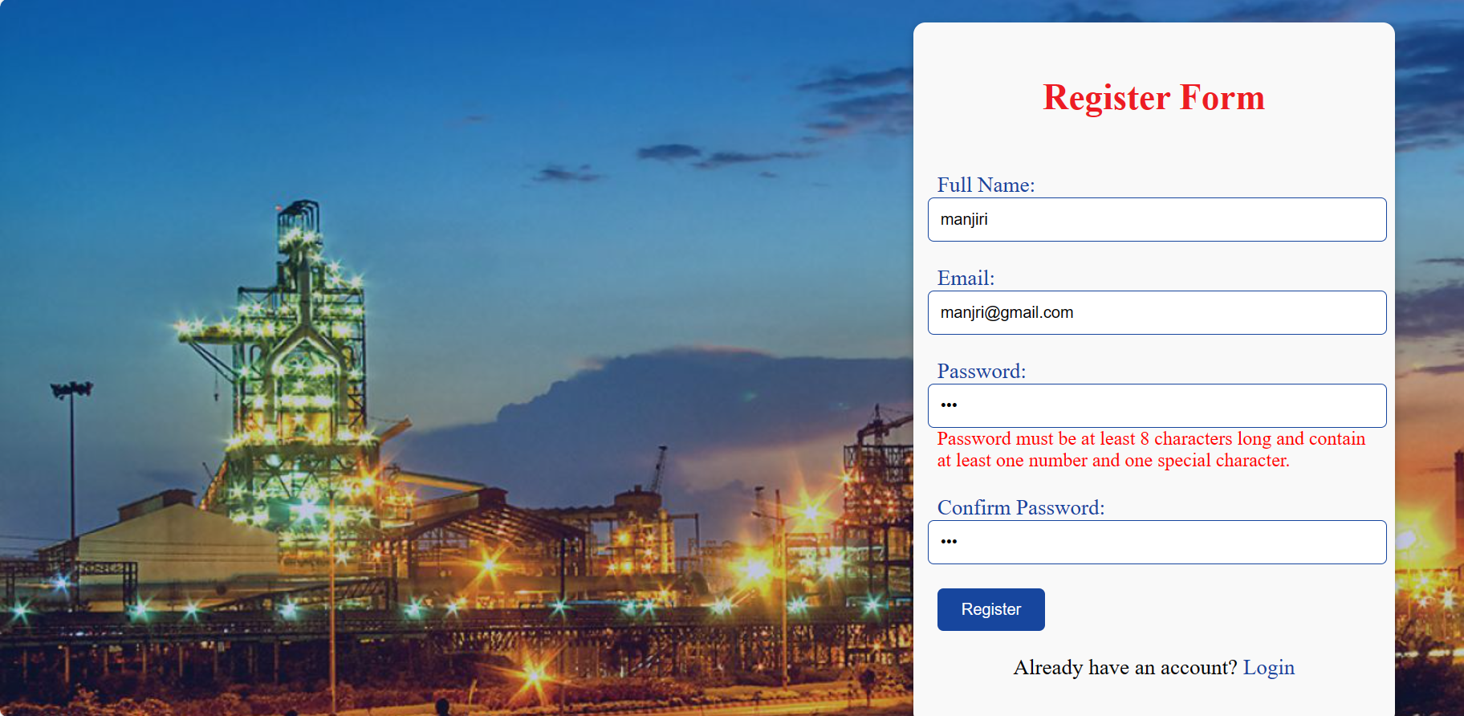

**Database For Registration Page:**

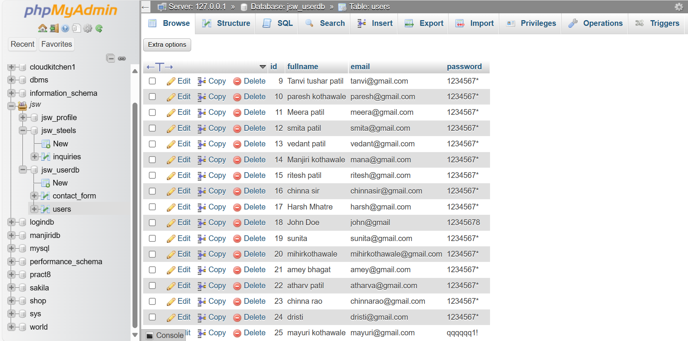

1. **Shop Page:**

The shop.php page serves as the central hub of the website after user login.

* Upon successful login, the shop.php page welcomes users by displaying their email ID, providing a personalized experience.
* The page features a sub navigation bar that categorizes different steel products, enabling users to easily navigate to specific product categories based on their interests.
* Within the shop.php page, users can explore a range of steel products showcased through sliders, allowing for a dynamic and engaging browsing experience.
* Each product category within the sub navigation bar leads to dedicated pages for different steel products, offering detailed information and visuals to help users make informed decisions.

Overall, the shop.php page enhances user engagement by presenting a user friendly interface with organized navigation and compelling product displays.

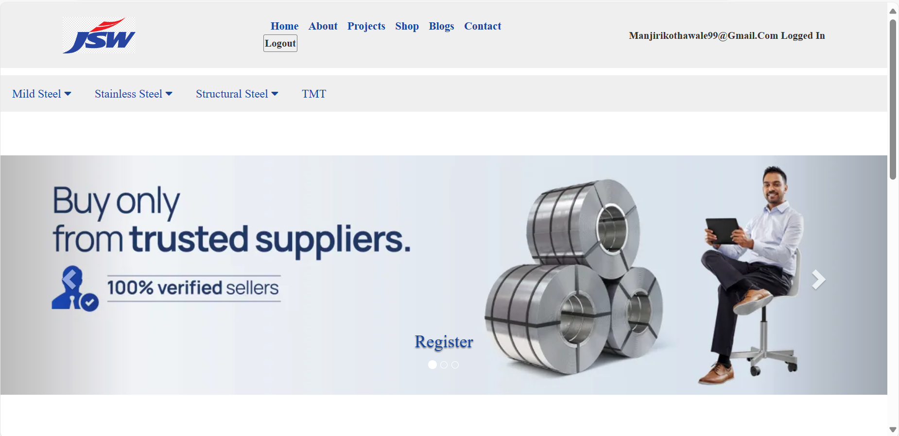

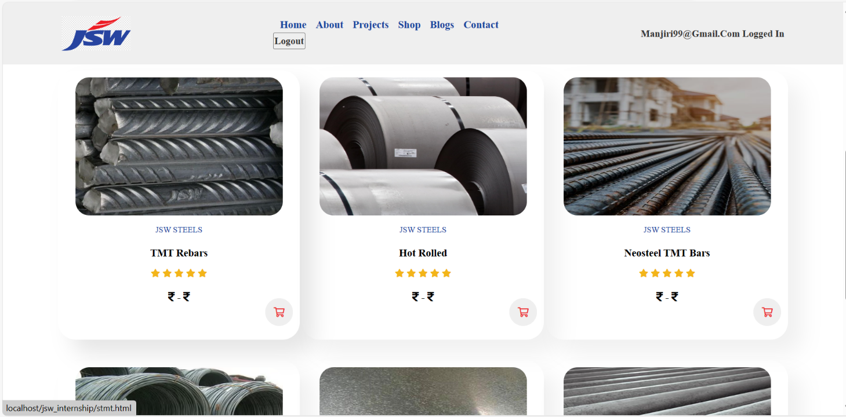

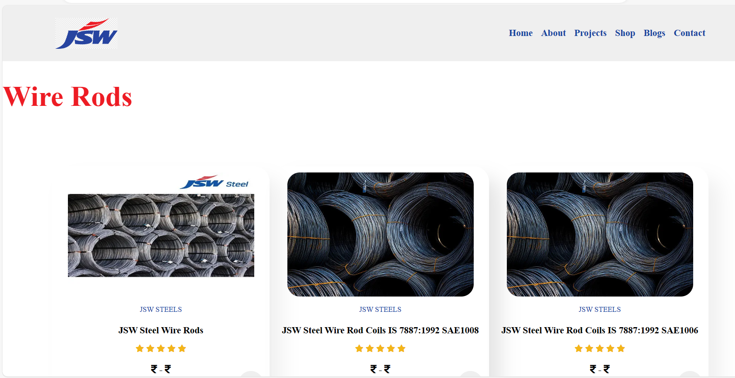

* Users can navigate to specific product categories, such as Hot rolled, from the sub navigation bar on the shop page.
* Upon selecting a product, like JSW Steel HRPO Coils IS 1079:2017 HR2, users are directed to a detailed product page (hotrolled.html), displaying comprehensive information about the selected product.
* The product page includes images of the selected product, providing users with a visual representation of what they are browsing.

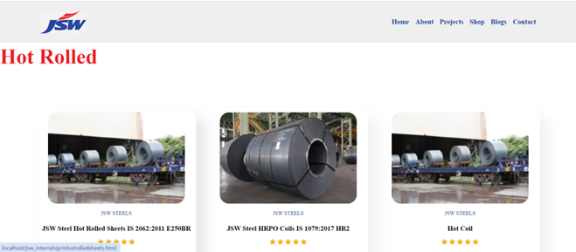

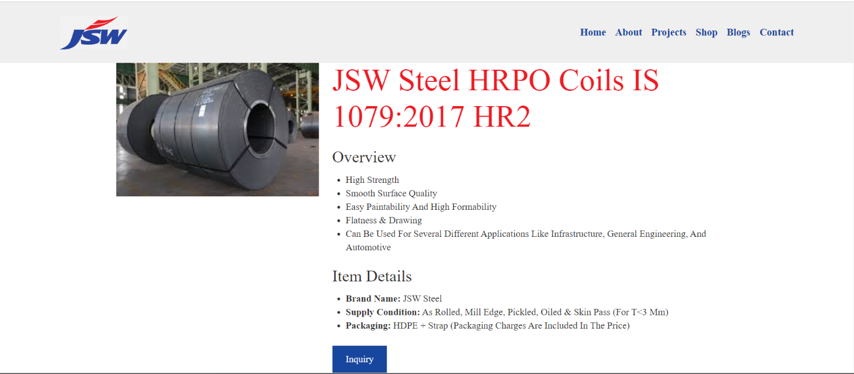

* When user will click on navigation bar you can select any product they want to buy and just click on that product option it will take them to the page where all product releated to that specific product category are present.
* Now if user wish to browse detailed information about any particular product they just need to click on that product image it will redirect to the page where it has all information of that product.
* If user wish to buy any product then there is a inquiry form which user need to fill.

1. **Inquiry Form:**

* Clicking on the Inquiry button triggers a popup form where users can submit inquiries regarding products or services.
* The form requires users to enter relevant details such as their full name, email address, phone number, company name, address, and specific requirements or messages related to their inquiry.
* The inquiry form is integrated with a backend database using PHP, ensuring that the information submitted by users is stored securely for future reference and processing.
* The form includes validation checks to ensure that required fields are filled out correctly. For example, email validation ensures that users enter a valid email address format.
* User data entered into the inquiry form is handled with care to maintain privacy and confidentiality, following data protection regulations and best practices.
* After filling out the form, users can submit their inquiry by clicking on a Submit button. A confirmation message or notification confirms that the inquiry has been successfully submitted.
* Integration with Backend Operations: The submitted inquiries are processed by backend operations, allowing the website's team to review, respond to, and manage inquiries efficiently.

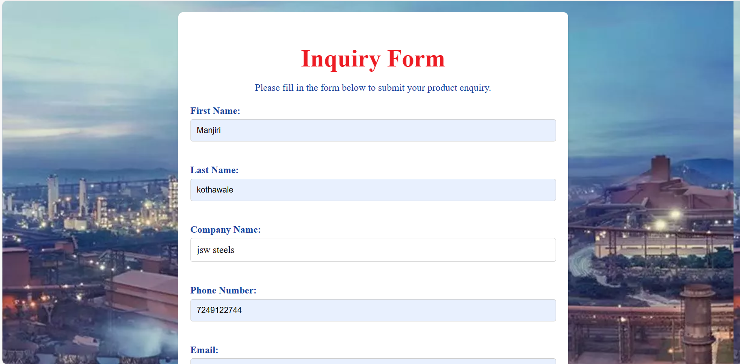

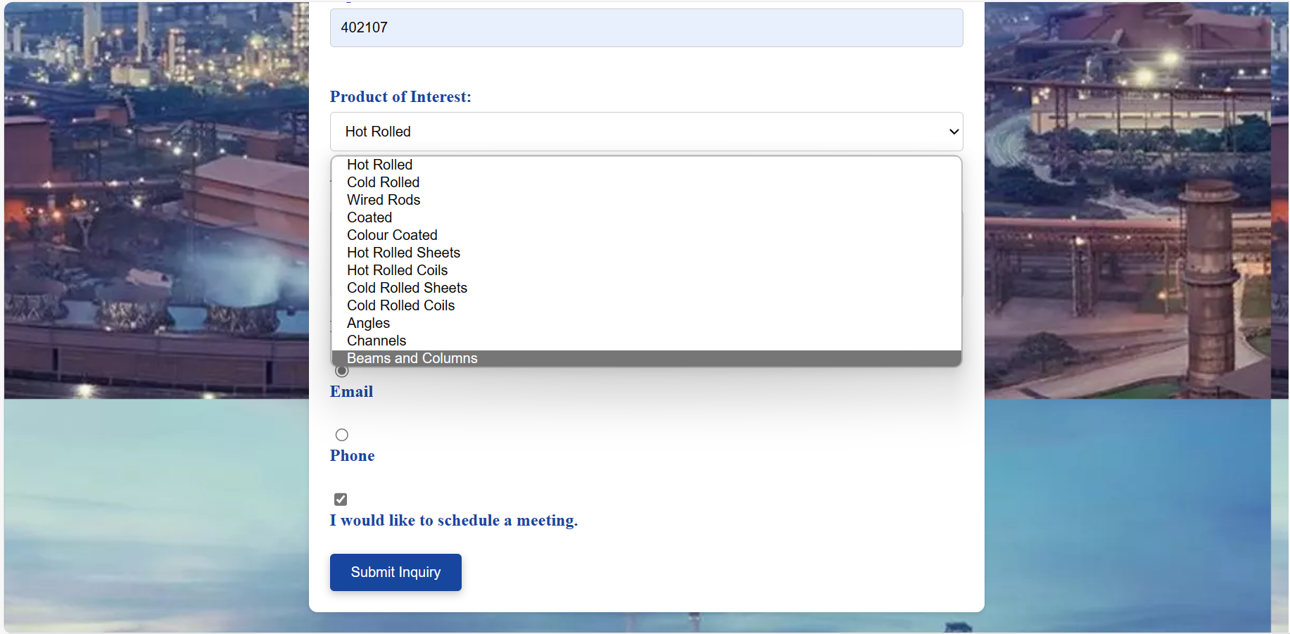

**AJAX Implementation:**

The Inquiry Form in our website utilizes AJAX (Asynchronous JavaScript and XML) to handle form submissions seamlessly. AJAX is employed to send form data to the server asynchronously, providing users with a smooth and interactive experience without reloading the entire webpage.

1. Asynchronous Form Submission: Upon clicking the Submit Inquiry button, the form data is sent to the server without requiring a full page refresh, enhancing user experience and reducing wait times.

2. jQuery AJAX Functionality: The form submission is managed using jQuery's AJAX function, which serializes the form data and sends it to the server using the POST method.

3. Server-side Processing: The form data is processed by a PHP script (`submit_inquiry.php`) on the server, handling validation, storage, and response generation.

4. Feedback Mechanism: Users receive immediate feedback upon successful form submission, with a Thank you for your inquiry! message displayed on the page.

5. Redirect Functionality: After a brief delay, users are redirected to the shop.php page, maintaining seamless navigation within the website.

**Inquiry Form Database:**

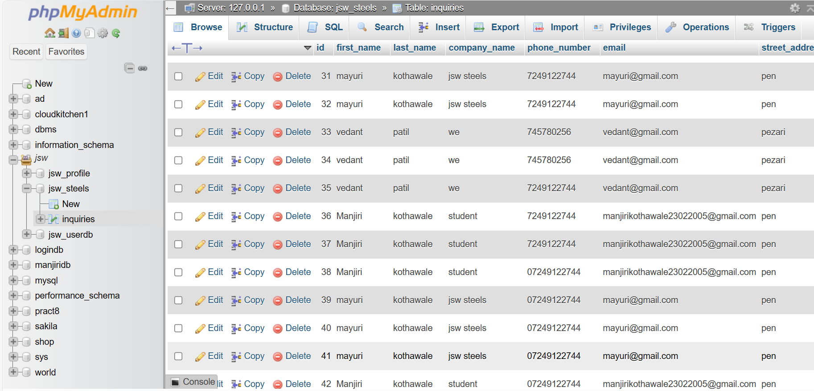

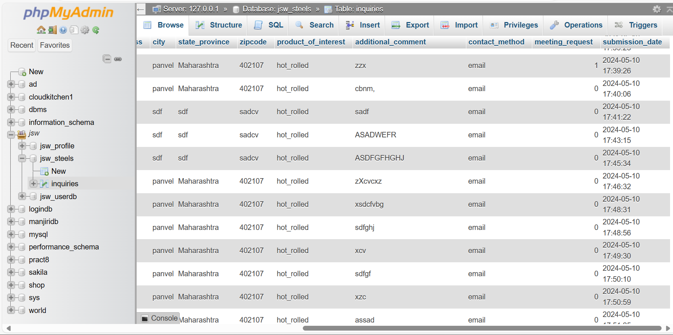

1. **Logout:**

A website features a logout button implemented using PHP sessions for user authentication. Clicking the logout button triggers the unset function to destroy the user session, ensuring secure logout. Upon logout, the user is redirected to the 'index.html' page. Additionally, JavaScript functionality is used to hide the login message after successful login, providing a seamless user experience.

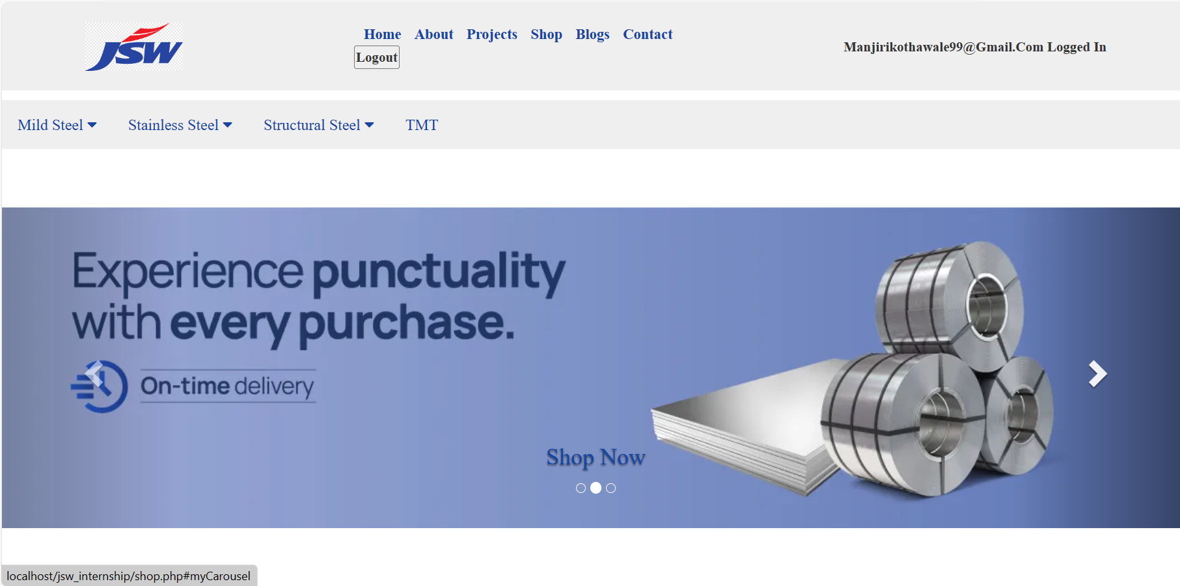

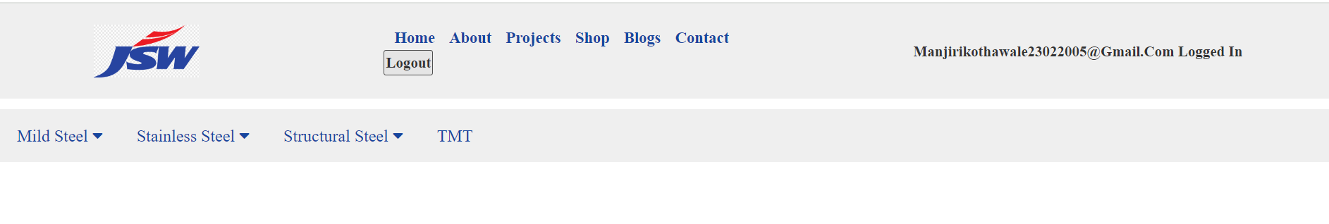

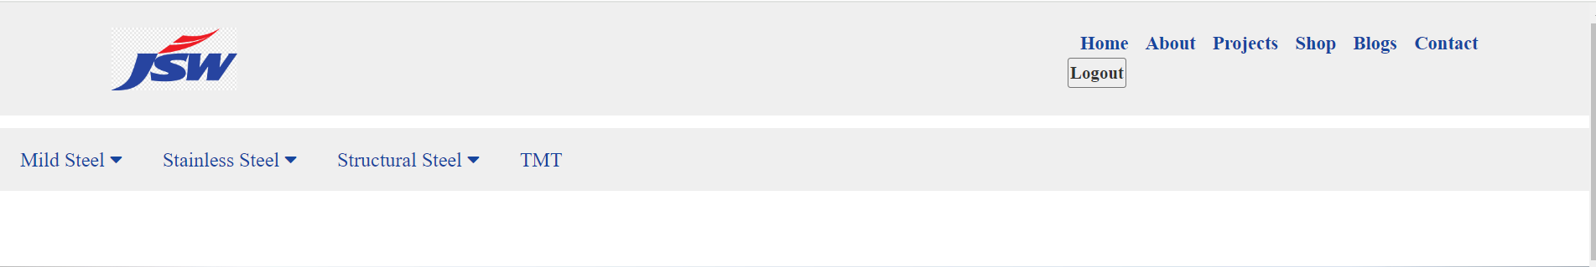

1. **Home Page:**

The homepage of the JSW Steels website, named 'index.html,' serves as the primary landing page for users. It features a responsive design with a clean layout optimized for various devices. The header includes the company logo, a navigation bar with links to different sections like 'home,' 'about,' 'projects,' 'shop,' 'blogs,' 'contact,' and a 'login' option for users. Additionally, there's an information icon for quick access to additional details.

The main section of the homepage showcases the company's identity and vision through compelling visuals and content. It highlights ‘JSW Steels Dolvi Works’ unique features, such as its integrated steel plant and advanced technologies like for steel-making and compact strip production. The content emphasizes the plant's capabilities in producing hot rolled coils and its contribution to various industries like automotive, industrial, and consumer durables.

Further down, the homepage presents a carousel slider featuring key sectors like automotive, machinery, and general engineering, each linked to relevant pages for more information. This dynamic element engages users and provides quick access to specific areas of interest.

The homepage also includes sections about the company's vision, mission, and values, offering insights into JSW's strategic direction, growth initiatives, and core principles. Each section provides a brief overview with the option to expand for more details, enhancing user engagement and understanding.

Towards the end, the footer section contains social media links for connectivity, essential information about JSW Steel Dolvi, product links, facilities, contact details, and copyright information. It's designed for easy navigation, accessibility, and providing comprehensive information about JSW Steels and its offerings.

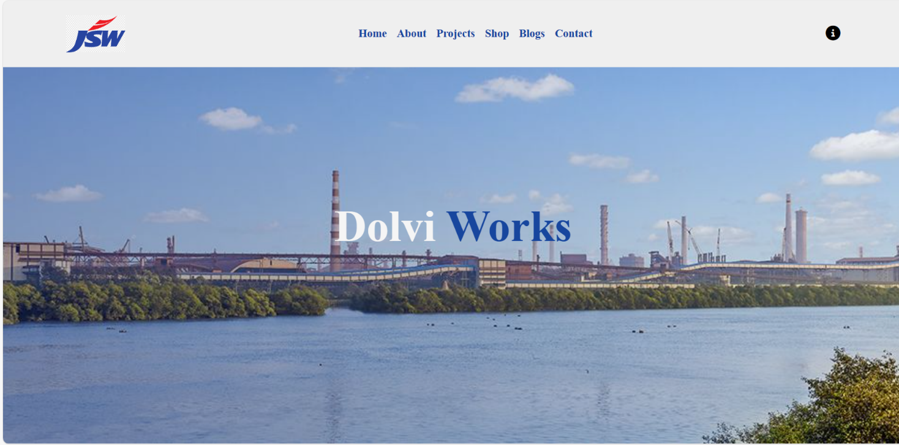

**Welcome section:**

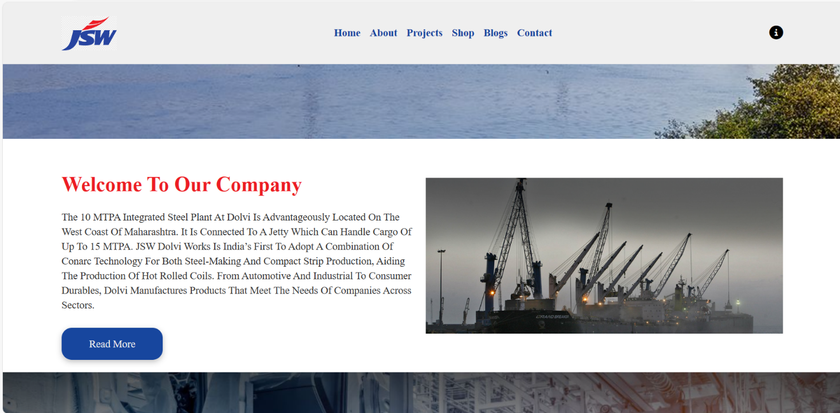

**Slider section:**

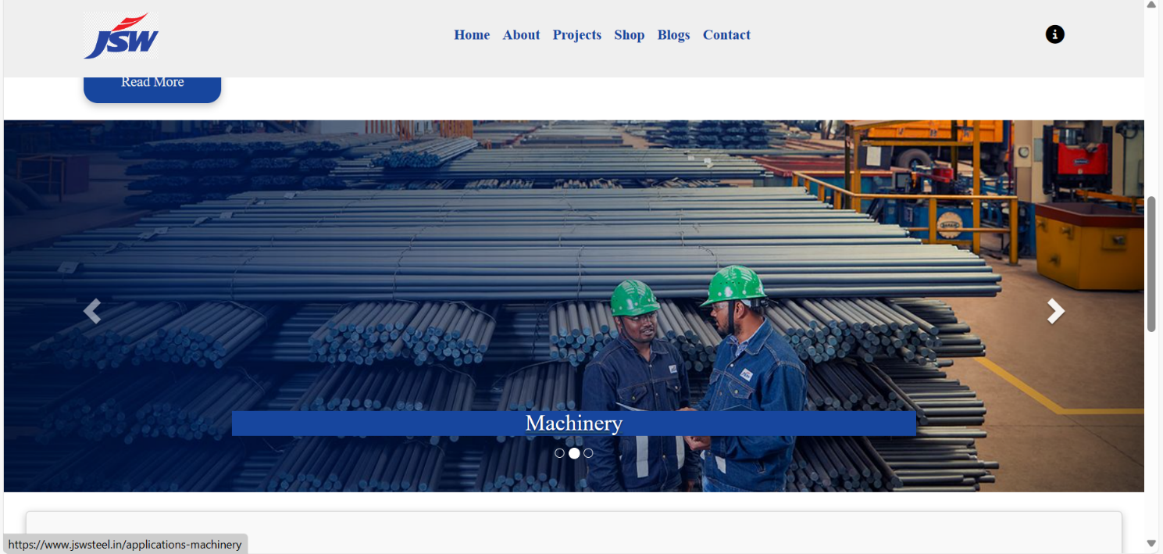

**Vision Mission and Values Section:**

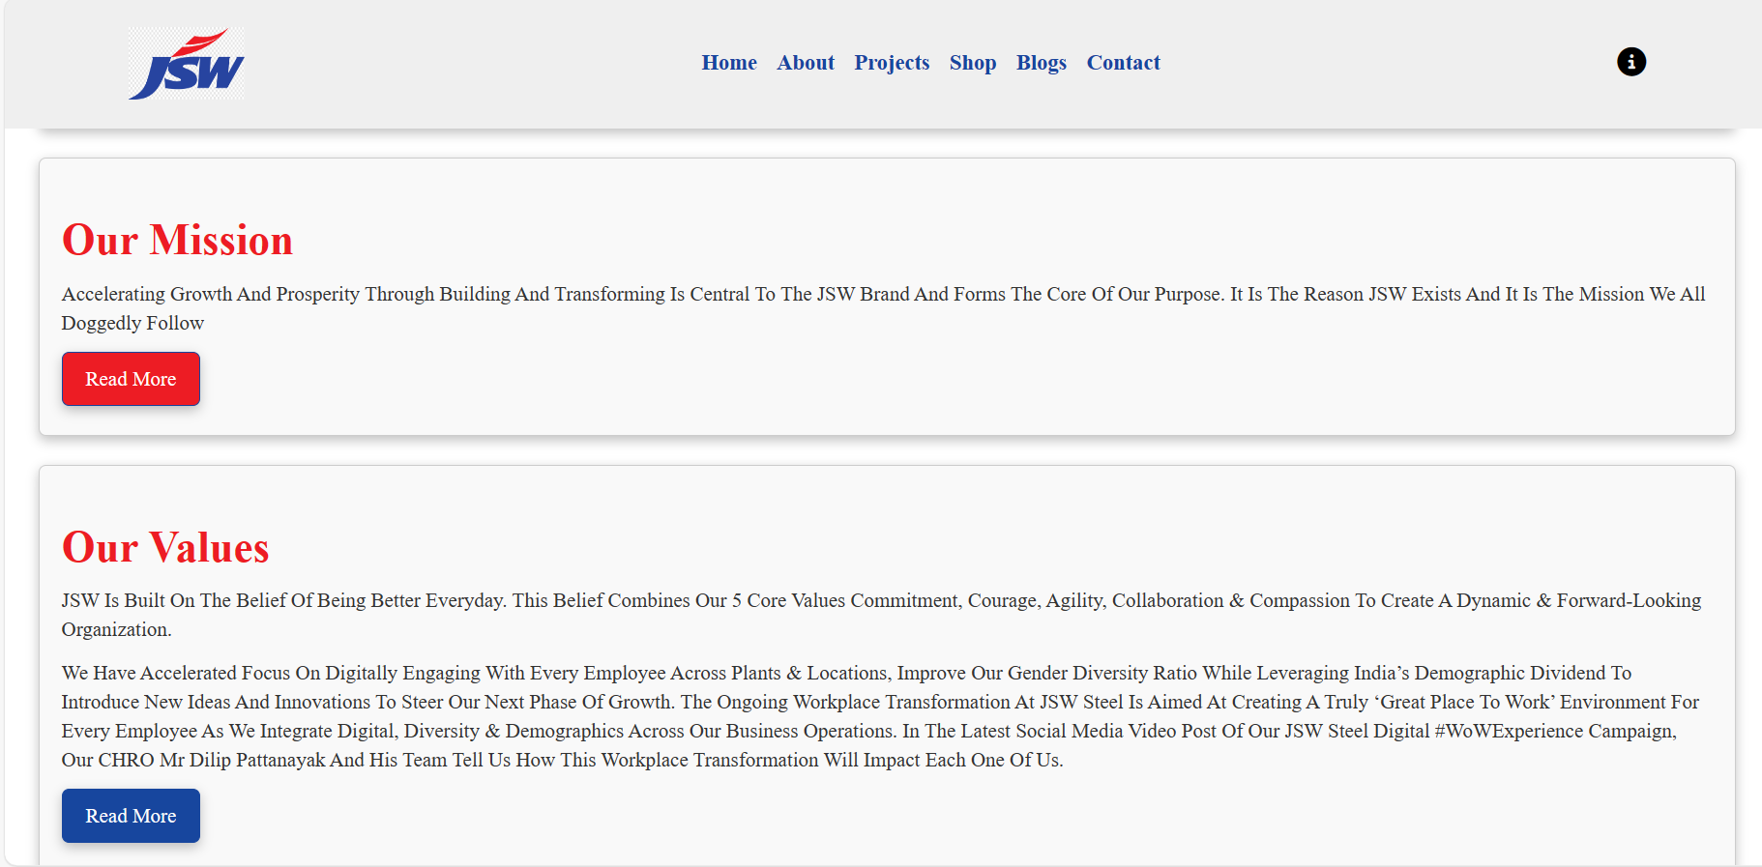

**Footer section:**

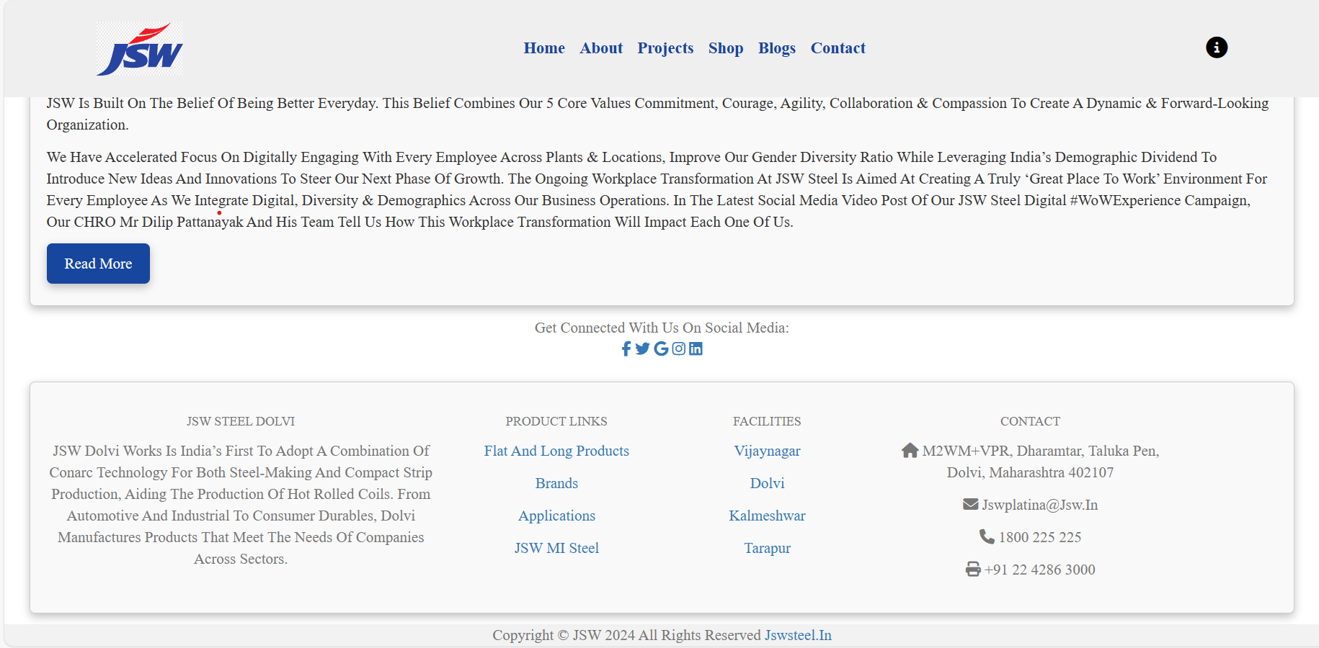

1. **About Us:**

The 'About Us' page on the website serves as a pivotal introduction to your brand and offerings. Upon redirection from the home page, visitors are greeted with a dynamic layout comprising several engaging elements:

1. Feature Section: This section highlights key aspects of your business, such as product quality assurance, timely delivery, hassle-free tracking, accessible after-sales services, and expert financial and operational advisory. Each feature is accompanied by relevant imagery to enhance visual appeal and convey your brand's strengths effectively.

2. Featured Product Section: Here, visitors can explore a curated selection of flagship products. Detailed descriptions, including product names, images, star ratings indicating customer satisfaction, and price ranges (in rupees), create a compelling showcase of your offerings.

3. Video Presentation: A pivotal component of 'About Us' page is the inclusion of a video presentation. This multimedia element offers a deeper insight into your brand story, values, and unique selling propositions. The embedded video, hosted on a reputable platform like YouTube, provides a rich visual experience for visitors, enhancing engagement and understanding.

4. Register Button: Strategically placed within the banner section, the 'Register' button encourages visitors to take actionable steps towards engaging with your brand. By clicking this button, users are directed to the registration page, facilitating seamless onboarding and conversion of potential leads into registered users or customers.

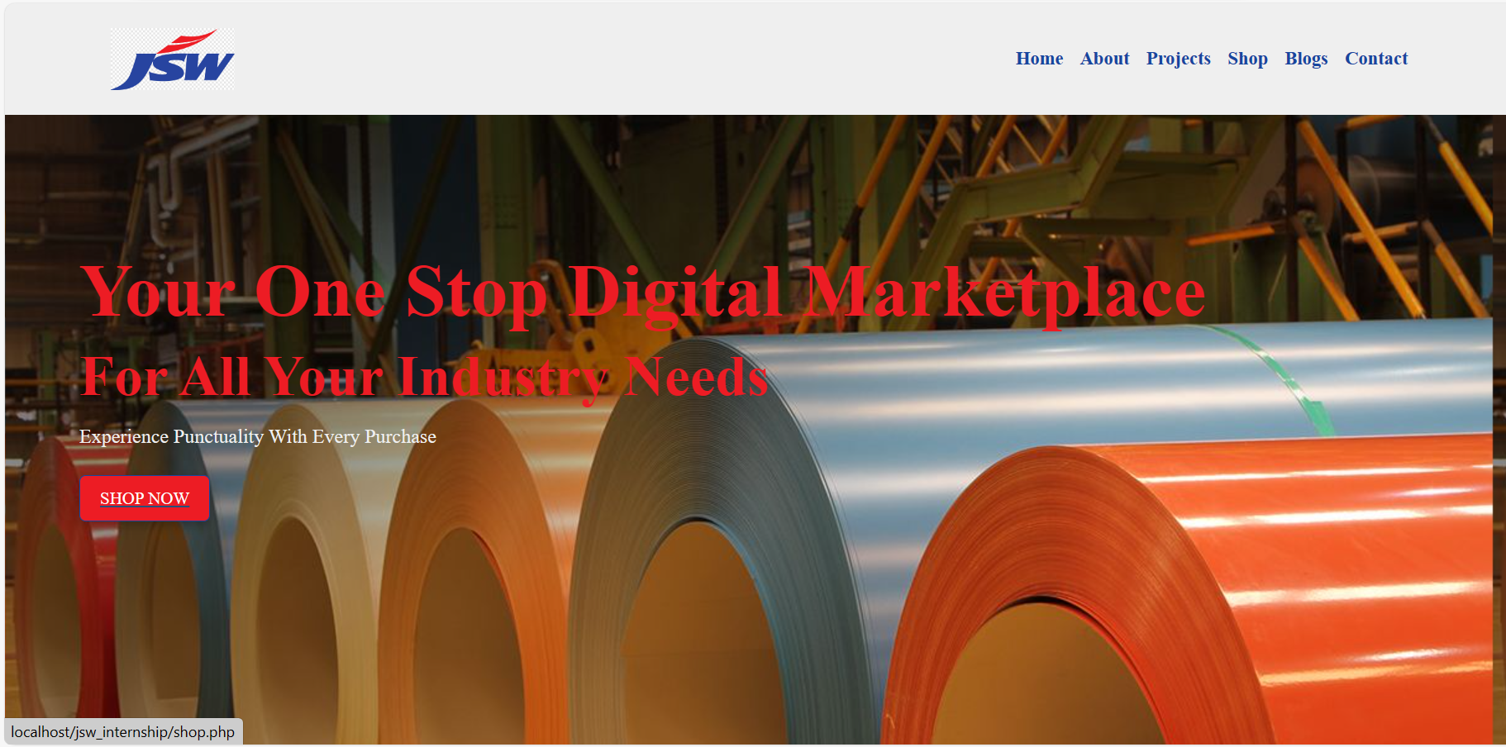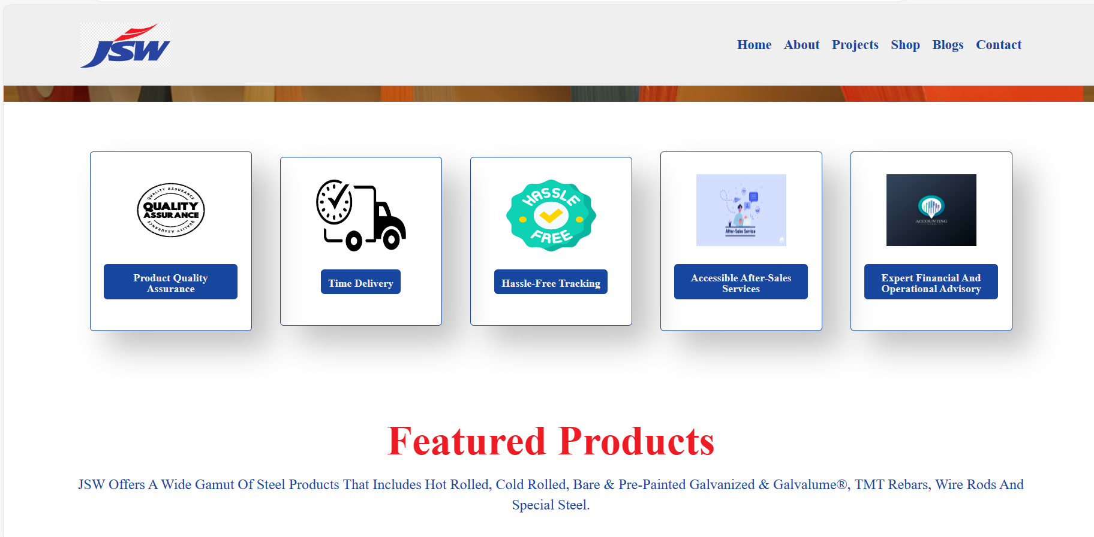

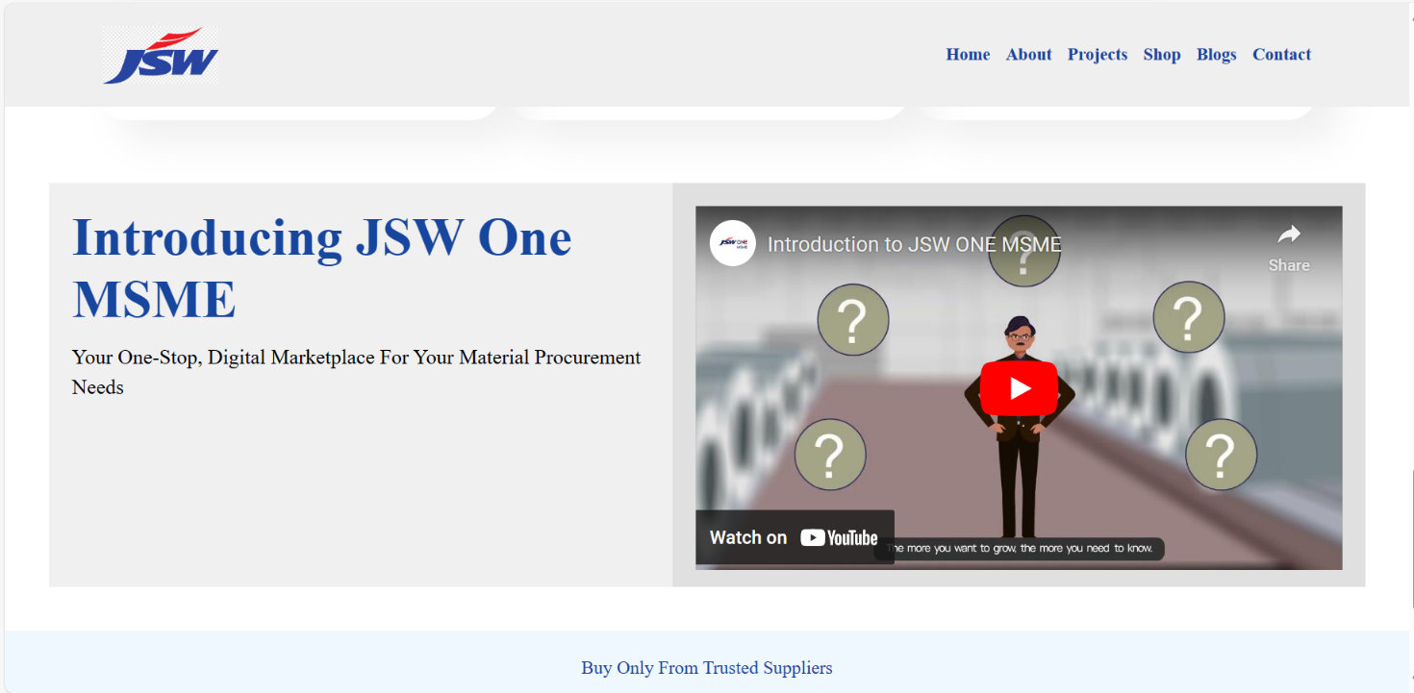

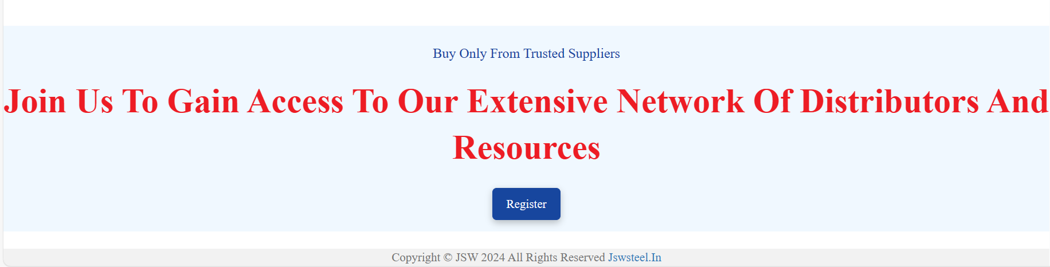

1. **Projects Page:**

The 'Projects' page on the website offers a comprehensive view of JSW Steel Dolvi's notable projects, showcasing the brand's diverse portfolio and significant contributions across various sectors. The page is designed to engage visitors and provide insights into the company's impactful initiatives:

1. Project Highlights: Each project is highlighted with an accompanying image, project name, and a brief description. This format allows visitors to quickly grasp the essence of each project and its significance within JSW Steel's operations.

2. Interactive Links: The inclusion of 'Read More' buttons with embedded hyperlinks directs users to detailed information about each project. This interactive feature encourages further exploration and engagement, facilitating a seamless browsing experience for visitors seeking in-depth project insights.

3. Visual Appeal: The layout of the 'Projects' page is visually appealing, with a clean and organized design that enhances readability and user experience. The use of images alongside project descriptions adds visual context and reinforces the narrative of JSW Steel Dolvi's achievements and capabilities.

4. Social Media Integration: The footer section of the page includes links to JSW Steel Dolvi's social media profiles, enabling visitors to stay connected and informed about the latest updates, news, and developments from the company.

5. Contact Information: Additionally, the footer section provides essential contact information, including the company's address, email, phone, and fax numbers. This ensures accessibility for users who may have inquiries or wish to connect with JSW Steel Dolvi for collaborations or other purposes.

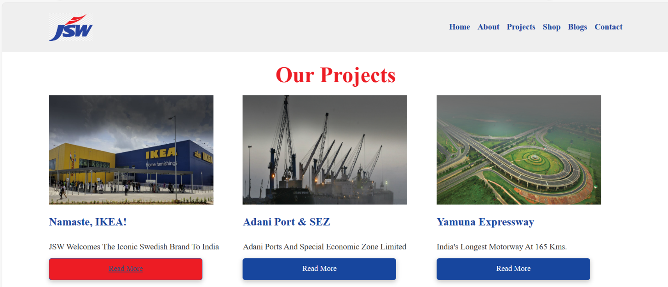

1. **Blogs Page:**

The blogs page of the JSW Steel website serves as a platform where users can access a collection of insightful and informative articles related to the steel industry. The page is designed with a user-friendly layout, featuring a header with the JSW Steel logo and navigation links to other sections of the website, such as the home, about, projects, shop, and contact pages.

The main content of the blogs page includes a series of blog posts, each presented with an image, title, brief description, and a "Read More" link that directs users to the full article on the JSW Steel website. The articles cover a range of topics, including technological advancements in steel manufacturing, innovations in grinding media technology, the science of corrosion protection, the role of TMT steel in sustainable construction, insights into alloy steel, sustainable building practices using corrugated sheets, economic impacts of steel companies, benefits of GI metal sheets for roofing, and the future of steel manufacturing.

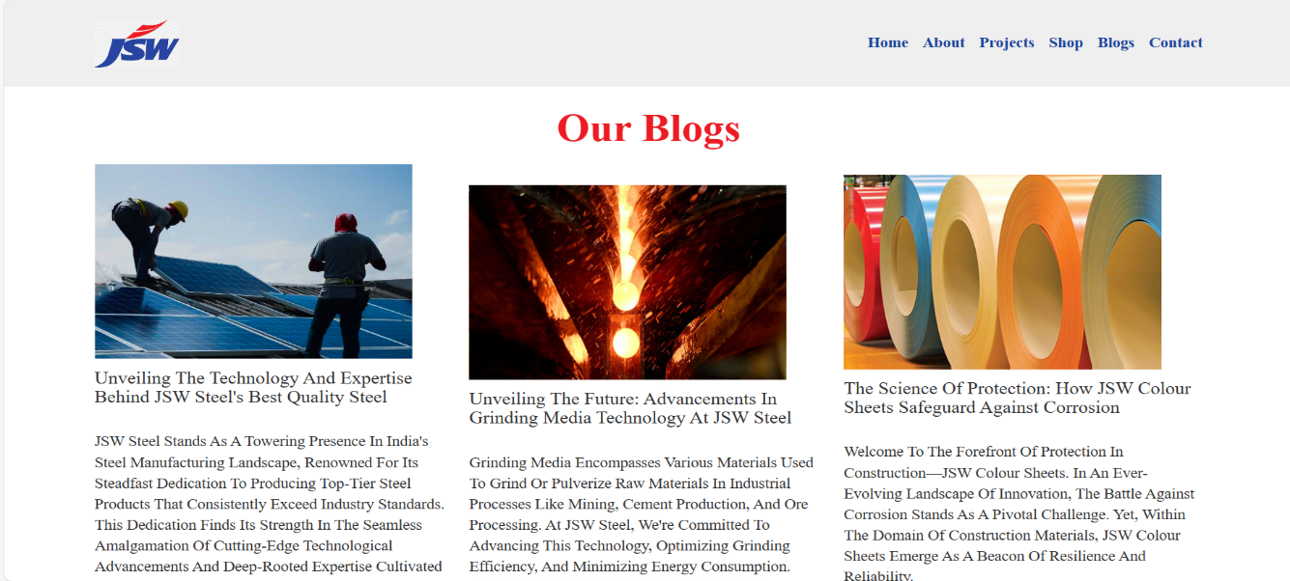

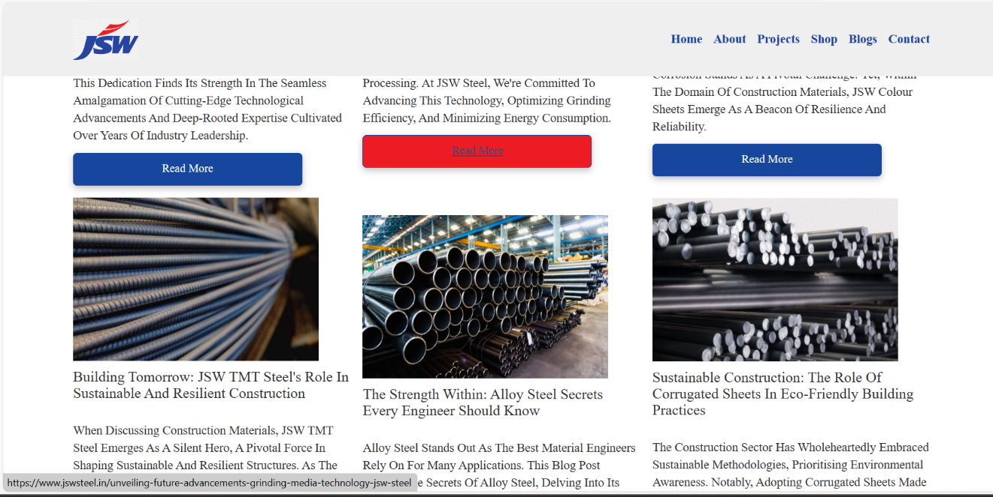

1. **Contact Us Page:**

* The "Contact Us" page of the JSW Steel website provides users with a convenient way to get in touch with the company for inquiries, general questions, career opportunities, partnerships, retail queries, media contacts, and investor relations. The page features a dropdown menu where users can select their purpose for contacting, ranging from product and service inquiries to specific business interests.
* Upon selecting a purpose, users are prompted to fill out a contact form with their first name, last name, email address, and a message detailing their inquiry or feedback. The form includes client-side validation to ensure that essential fields are filled correctly, enhancing user experience and data accuracy.
* The design of the page is visually appealing, with an image banner showcasing the company's branding and a clear header navigation menu for easy access to other sections of the website. Social media links are provided in the footer, allowing users to connect with JSW Steel across various platforms.
* Behind the scenes, the page is powered by PHP scripting for server-side processing of the contact form. Upon form submission, the data is securely transmitted to a MySQL database, where it is stored for internal use. Users receive a confirmation message upon successful submission, reinforcing a positive interaction experience.

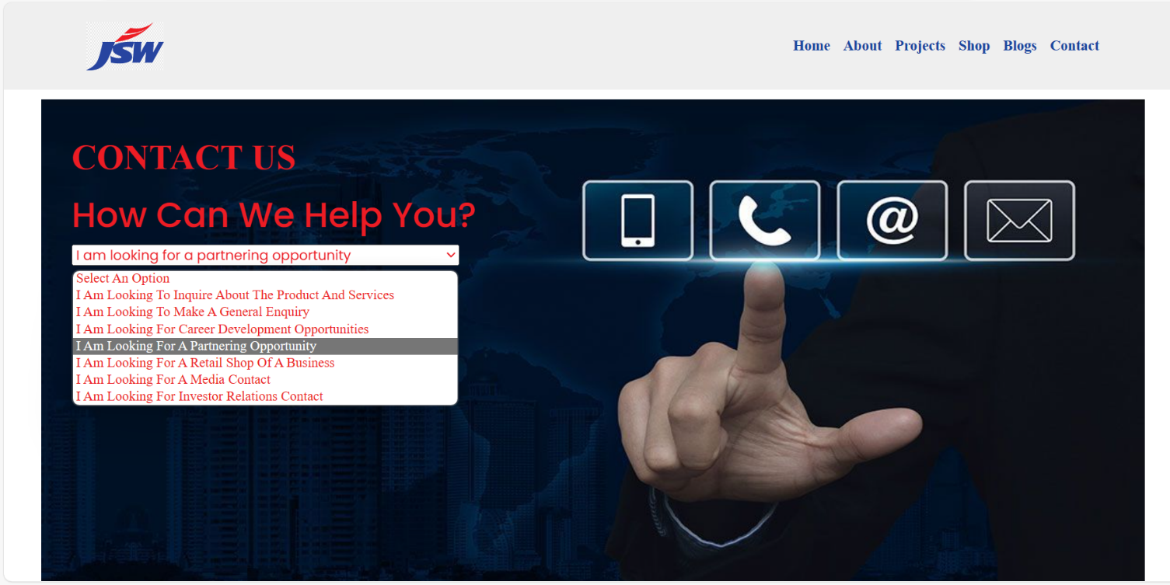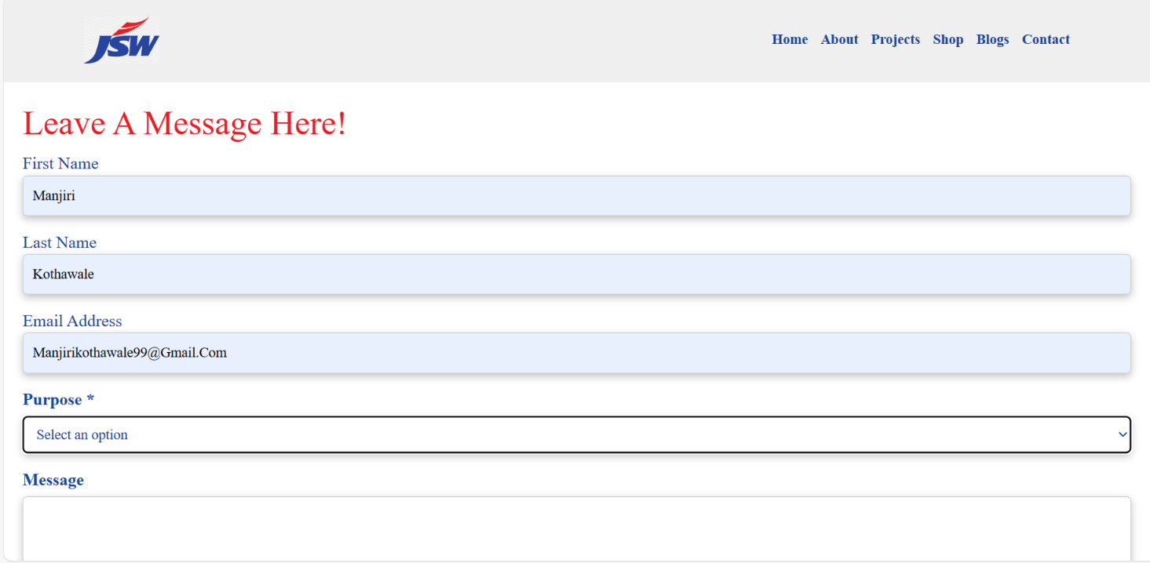

**Contact Us Database:**

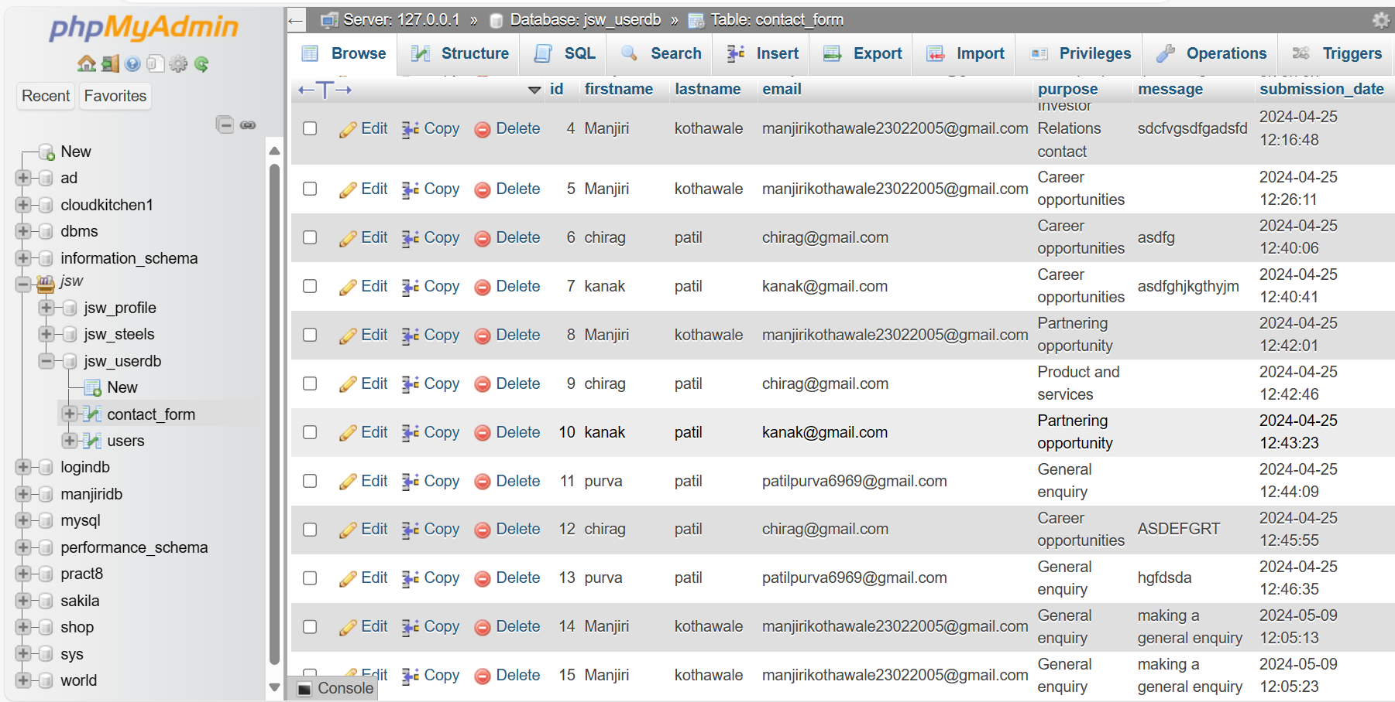

**DATABASE**

A database is a structured collection of data that is organized and stored for easy access, retrieval, and management. It serves as a central repository where information can be stored, updated, and retrieved as needed. Databases are crucial in modern computing because they provide a structured way to store and manage vast amounts of data efficiently.

MySQL, on the other hand, is a popular open-source relational database management system (RDBMS) that is widely used for managing structured data. It uses Structured Query Language (SQL) to interact with databases. MySQL is known for its reliability, scalability, and performance, making it a preferred choice for many applications, from small-scale websites to large-scale enterprise systems.

In essence, MySQL is a software that allows users to create, manage, and interact with databases using SQL queries. It provides features such as data security, transactions, indexing, and replication, making it a powerful tool for building and managing databases in various applications.

In JSW Steel e-commerce project, the database plays a crucial role in storing and managing various aspects of the business, including user information, product details, and contact inquiries. Here's an overview of the database structure based on our recent conversations and project requirements:

1. Users Table:

* This table stores user information such as user ID, full name, email address, password (hashed for security), and any other relevant details related to user accounts.
* The database includes functionalities for user registration, login, and authentication using PHP and MySQL, ensuring secure access to the website's features and personalized experiences for users.

2. Contact Form Entries:

* When users submit inquiries or messages through the contact form on the website's "Contact Us" page, the data is stored in a separate table. This table captures details such as the sender's name, email address, purpose of contact, message content, and timestamps.

3.Inquiry Table:

* This table likely stores information related to inquiries made by users, such as their name, email, company name, phone number, address, inquiry type or purpose, and any additional comments or messages they provide.

4. Database Connectivity:

* The PHP scripts used for user registration, login, product management and contact form handling interact with the MySQL database using SQL queries.
* Secure database connections and proper data validation techniques are implemented to prevent SQL injection attacks and ensure data integrity.

**SNIPPETS OF STRUCTURES OF DATABASE**

**Users table:**

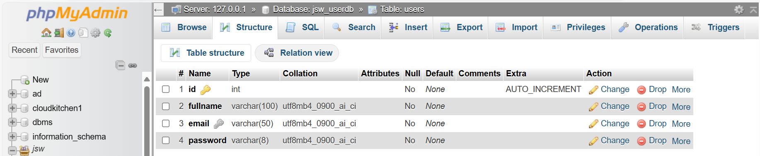

**Contact Form Table:**

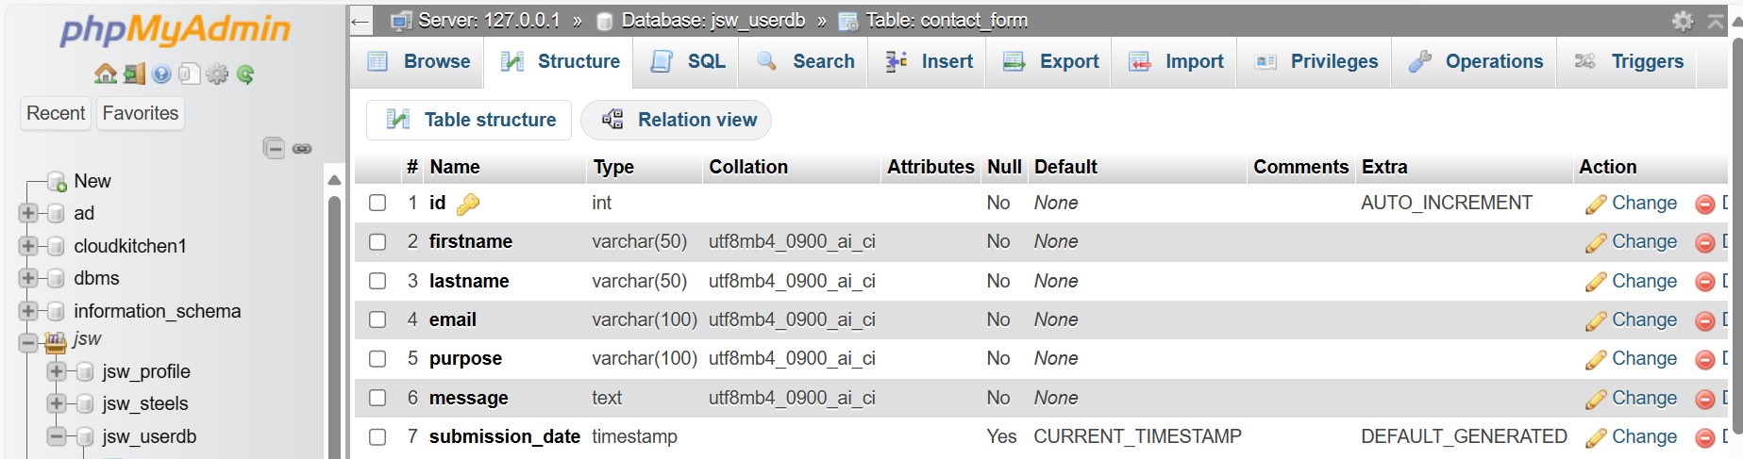

**Inquires Table:**

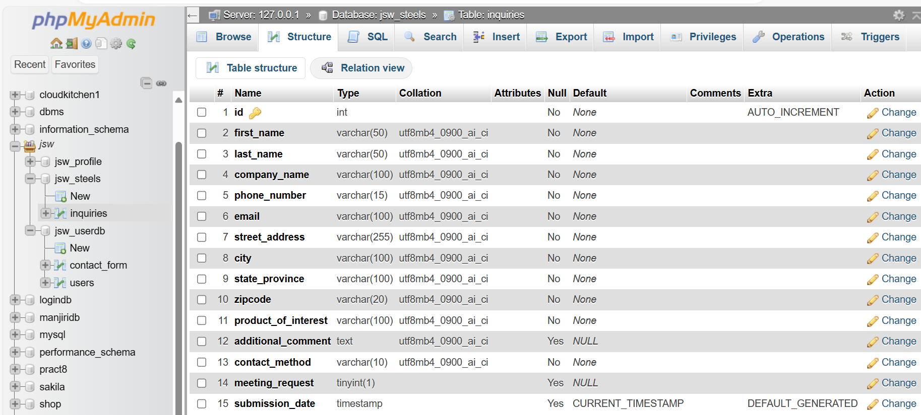

**DEPLOYMENT**

**Server used: XAMPP Apache-MySQL Server**

XAMPP is a popular tool used for local development and deployment of web applications. It provides an environment that includes Apache as the web server, MySQL as the database management system, PHP as the scripting language, and Perl for various tasks. Deploying your web application with XAMPP involves configuring and optimizing this environment for seamless operation.

**1. Purpose and Use:**

* XAMPP is a free and opensource cross platform web server solution stack package developed by Apache Friends.

**2. Key Components:**

* Apache HTTP Server: Provides the web server functionality, allowing hosting of websites and web applications locally.
* MySQL Database: A relational database management system (RDBMS) for storing and managing structured data.
* PHP: A server-side scripting language used for dynamic web content generation and interaction with databases.
* phpMyAdmin: A web based application for managing MySQL databases through a graphical user interface (GUI).

**3. Features:**

* Local Development Environment: XAMPP creates a local server environment on your computer, simulating a live web server for testing and development purposes.
* PHP Support: XAMPP supports PHP, allowing developers to write serverside scripts for dynamic web applications.
* Apache Server: The Apache HTTP Server in XAMPP serves web pages and handles HTTP requests from web browsers.

**Testing and Troubleshooting**

* Testing: Perform thorough testing of the deployed website on the local XAMPP server to ensure all functionalities work as expected.
* Troubleshooting: In case of any issues, check the XAMPP error logs located in the XAMPP installation directory for clues on debugging and resolving issues.

**SWOT ANALYSIS**

* **Strengths:**

1. Wide Product Range: Offering a variety of products such as coils and sheets caters to diverse customer needs, attracting a broader audience.
2. Secure Payment Gateways: Integration of secure payment gateways enhances customer trust and facilitates smooth transactions.
3. Responsive Design: Implementing media queries ensures a seamless user experience across devices, improving accessibility and user satisfaction.
4. Brand Reputation: Leveraging the reputation and trust associated with the JSW Steel brand enhances credibility and attracts customers who value quality and reliability in steel products.
5. Customer Support: Providing excellent customer support through multiple channels such as live chat, email, and phone support ensures prompt assistance, resolves queries, and builds positive relationships with customers.
6. Customization Options: Offering customization options for steel products, such as size variations, coatings, and packaging, provides customers with personalized choices, enhancing their buying experience and meeting specific requirements.

* **Weaknesses:**

1. Complexity in Development: Integrating features like a database, inventory management can be complex and time-consuming, requiring meticulous development and testing.
2. Limited Market Reach: Depending solely on online sales may limit market reach, especially in regions with lower internet penetration or where traditional channels are more prevalent. Exploring offline distribution channels or partnerships could address this limitation.
3. Technical Dependencies: Relying heavily on technical infrastructure and third-party services for website functionality, such as hosting providers, payment gateways, or inventory management systems, introduces vulnerabilities to system failures, downtime, or compatibility issues.
4. Scalability Challenges: As the business grows and customer demand increases, scalability challenges may arise in terms of inventory management, order processing, and website performance. Ensuring scalability through robust systems and processes is essential to meet future growth needs.
5. Competitive Pricing Pressure: Operating in a competitive market with price-sensitive customers may lead to pricing pressure and margin constraints. Balancing competitive pricing with profitability is a constant challenge that requires strategic pricing strategies.
6. Data Security Concerns: Managing sensitive customer data, payment information, and privacy concerns requires robust data security measures, compliance with data protection regulations, and ongoing monitoring to prevent data breaches or cyberattacks.

* **Opportunities:**

1. Expansion of Product Range: Adding more products related to steel manufacturing or complementary industries can attract a wider customer base and increase sales.
2. Enhanced Marketing Strategies: Implementing targeted marketing campaigns, SEO optimization, and social media integration can boost website traffic and customer engagement.
3. International Market Reach: Leveraging the website's capabilities to offer products internationally can tap into new markets and increase revenue streams.
4. Continuous Improvement: Regular updates and improvements to the website based on customer feedback and market trends can enhance user experience and competitiveness.
5. Certainly, let's reframe those points as opportunities and weaknesses:
6. Secure Payment Gateways: Integrating secure payment gateways presents an opportunity to enhance the website's credibility and build trust among customers. This secure transaction process can lead to increased customer confidence, higher conversion rates, and reduced cart abandonment rates, ultimately improving overall sales performance.
7. Order Confirmation Emails: Implementing order confirmation emails as part of the customer communication strategy creates an opportunity to enhance post-purchase satisfaction. These emails provide customers with reassurance about their orders, including details and delivery timelines, leading to a positive shopping experience. Effective post-purchase communication can also encourage repeat purchases and foster customer loyalty.

* **Threats:**

1. Cybersecurity Risks: The increasing prevalence of cyber threats such as data breaches, hacking attempts, and malware attacks poses a significant threat to the security of customer data, payment information, and the overall integrity of the website. Failure to implement robust cybersecurity measures can result in financial losses, reputational damage, and loss of customer trust.
2. Competitive Market: The steel e-commerce market is highly competitive, with numerous players offering similar products and services. Intense competition can lead to price wars, aggressive marketing tactics, and challenges in differentiating your brand. Failure to effectively position your website in the market or differentiate from competitors can impact market share and profitability.
3. Economic Volatility: Fluctuations in steel prices, currency exchange rates, and economic conditions can impact consumer spending behavior and purchasing power. Economic downturns or instability may lead to reduced demand for steel products, affecting sales and revenue generation for the website.
4. Regulatory Compliance: Adhering to complex regulatory requirements such as data protection laws (GDPR, CCPA), consumer rights, tax regulations, and trade policies is a constant challenge. Non-compliance can result in legal consequences, fines, and reputational damage, posing a threat to the business operations and customer trust.
5. Technology Disruptions: Rapid advancements in technology and changing consumer preferences can lead to technological disruptions. Failure to adapt to emerging technologies, such as mobile responsiveness, AI-driven customer experiences, or innovative payment solutions, can result in a loss of competitiveness and relevance in the market.
6. Supply Chain Disruptions: Dependence on suppliers for raw materials, inventory, and logistics poses a threat to the supply chain resilience. Disruptions such as supply shortages, logistics delays, or quality issues can impact product availability, order fulfillment, and customer satisfaction. Developing contingency plans and diversifying supply sources can mitigate these risks.

**CONCLUSION**

During my training at JSW Steel, Dolvi, I had an enriching and transformative experience that left a lasting impact on me. The learning environment was vibrant and dynamic, filled with opportunities to grow and learn alongside talented individuals. Each day presented new challenges and learning moments, allowing me to develop practical skills that I can apply in real-world scenarios.

The collaborative atmosphere at JSW Steel was truly exceptional. I was welcomed warmly into the team and given meaningful responsibilities that made me feel like a valued contributor. Working on various projects allowed me to immerse myself in different aspects of the industry, from technical processes to project management.

One of the highlights of my experience was the opportunity to deploy my application on JSW Steel's servers. This not only showcased my technical abilities but also contributed to the company's operational efficiency. Being part of such a significant deployment process was both fulfilling and educational, highlighting the importance of collaboration and attention to detail in a professional setting.

Overall, my time at JSW Steel, Dolvi, was a journey of growth, learning, and meaningful connections. I am grateful for the support, mentorship, and experiences that have shaped me into a more skilled and confident professional.

**REFERENCES:**

<https://www.jswonemsme.com/>

<https://www.jswsteel.in/dolvi-works>

<https://www.youtube.com/>

<https://fontawesome.com/>

<https://chat.openai.com/>

**Website Link:** [JSW STEELS](http://localhost/jsw_internship/login.php)